NETWORK FUNDAMENTALS LABS

Prepared by : Ramy Magdy

# LABS

##### labs are proving the theoretical concepts that have been taught in lectures and enhance the technical skills for learners

HOW TO PREPARE YOUR PC TO DO THE LABS EFFECTIVELY?

1. **It is preferred that you do your labs and Assignments in your Virtual Machine not on your original operating systems.**

*To setup A Virtual Machine on your pc see “index”*

1. **During Testing Don’t forget to**
   1. **Turn off Firewall Both on Client and Server PCs**
   2. **Turn off Firewall of any Antivirus Both Client and Server.**
   3. **Test Connectivity between Client and Server.**
   4. **Do not use Proxy Server on Both Client and Server PCs**
2. **After finshed your labs don’t forget to:**
   1. **Uninstall the programs you used**
   2. **Disabled the accounts you create**
   3. **Disables the rules you setup on firewall**
   4. **Enable your firewall and antivirus**
   5. **Use your proxy server**

# Labs

**In these labs, you will learn how to Configure TCP/IP Protocols on your pcs (Clients & Servers) and prove the theoretical concepts that have been taught in lectures which will enhance your technical skills**

**Network Lab**

**Configuring your IP address**

##### Building the network (Configuring your IP address )

* By default the DHCP (distribute IP address to Client) will give your PC an IP address if they are assigned to obtain an IP address automatically.

To know your current IP address (logical) use the command:

* + **1- Ipconfig Command**

#### Ipconfig

Gives details about your network settings

**Start** 🡪**cmd**🡪**ipconfig**

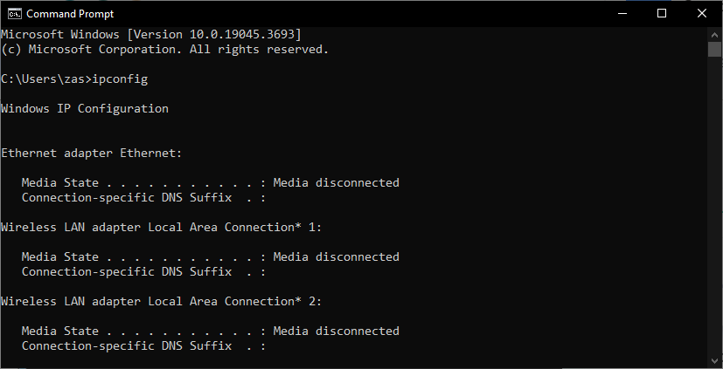

#### Ipconfig /all

Gives **more** details about your network settings

**Start** 🡪**cmd**🡪**ipconfig/all**

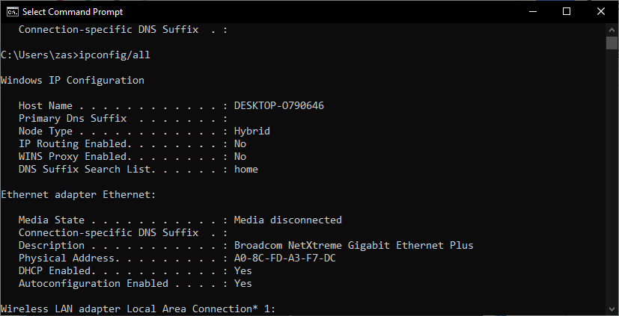

* + - 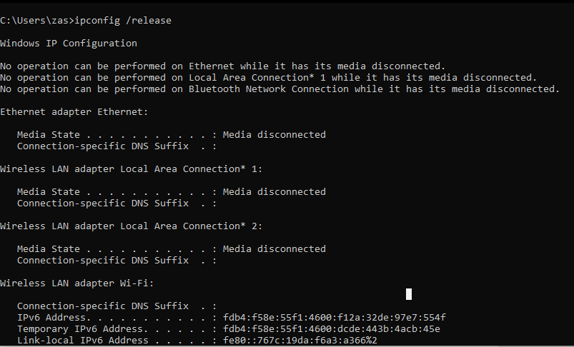**ipconfig /release** ---To Release the conflict or faulty IP Address.
    - **ipconfig /renew** --- To Request a new IP from a DHCP server

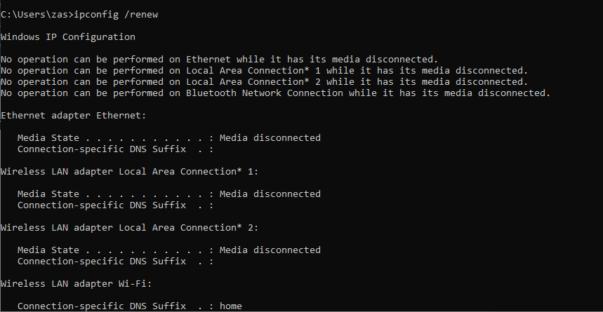

* IF there is a problem and your pc can’t get an IP address you can configure it Manually

* + **2- Configure IP address manually.**

**Start** 🡪**Control panel**🡪**Network and Internet**🡪**Network and sharing Center**

🡪 **In the Left panel Change Adaptor settings** 🡪 **select Local Area Connection adaptor**🡪 Double click and edit network settings 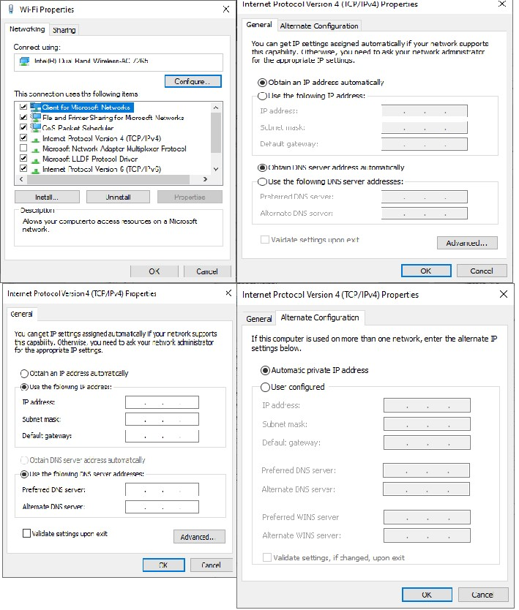

Click the Advanced button and you can add IP address, Gateway, DNS,..etc

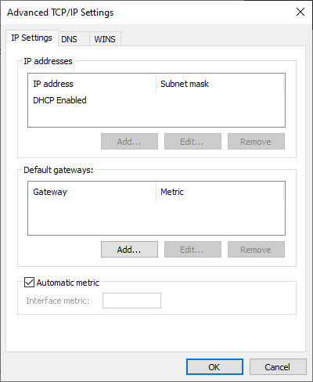

* To check the connectivity between devices use the

To know your Real IP (Static) address

Use website like as :

<https://whatismyipaddress.com/>

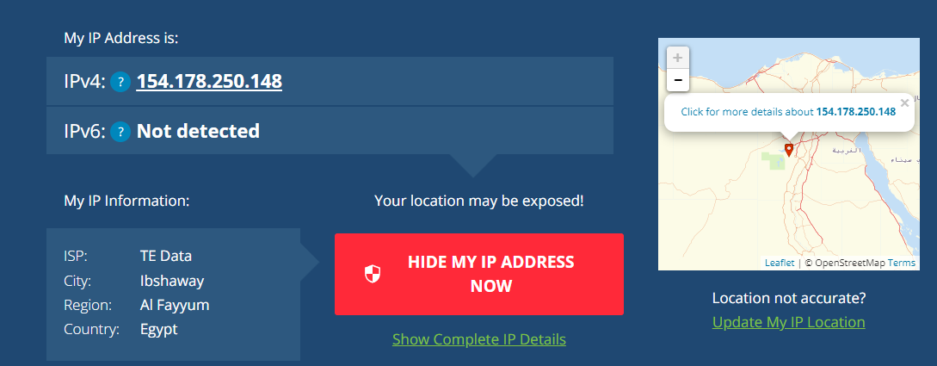

## 3- Ping Command

### Check the connectivity

**Ping *Destination IP Of_Remote_Host***

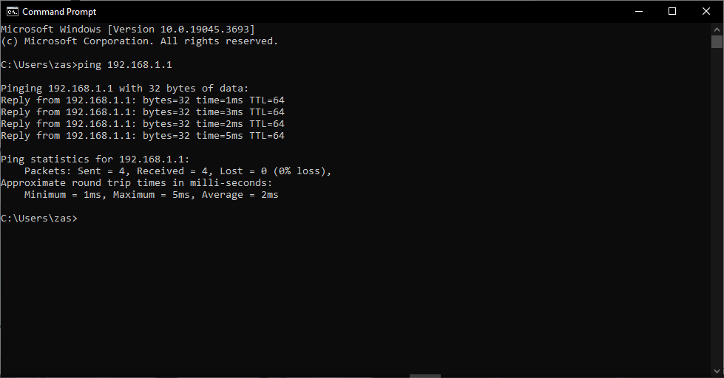- **Suppose that the remote host has the ip 192.168.1.1 C:\>ping 192.168.1.1**

### Check the Availability of website

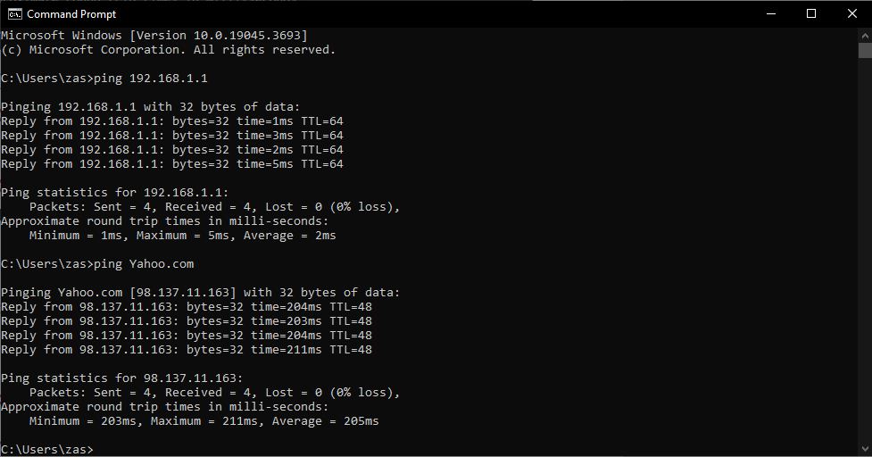**C:\>ping Yahoo.com**

* + - **Continue ping operation unlimited ( just add the switch "-t")**

**C:\>ping 192.168.1.1 -t**

**to exit write : ctrl+c**

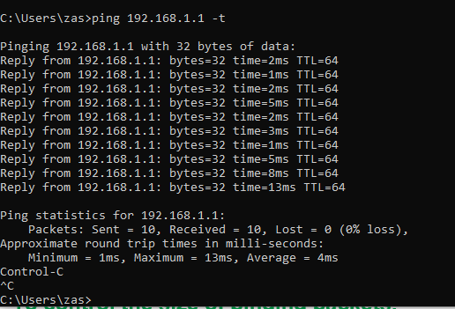

### To control the number of pinging packets,

**(just add the switch "-n" followed by the required packet number (space) )**

**C:\>ping 192.168.1.1 –n 7**

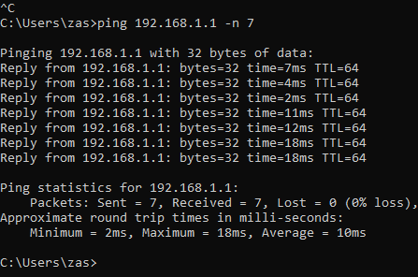

### To control the size of pinging packets,

**(just add the switch "-l" followed by the required packet size)**

**C:\>ping 163.121.25.40 -l 2000**

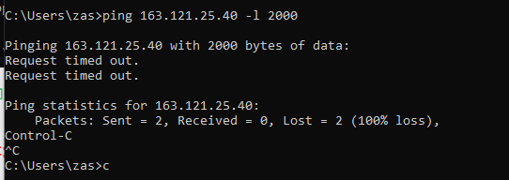

**C:\> Ping 163.121.12.40 -l 2000 –n 6**

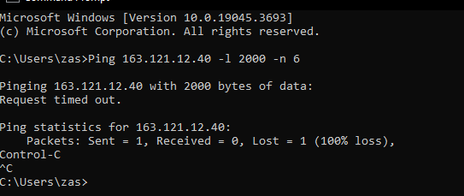

Reply from 163.121.12.40: **bytes=2000** time=1ms TTL=128 Reply from 163.121.12.40: bytes=2000 time=1ms TTL=128 Reply from 163.121.12.40: bytes=2000 time=1ms TTL=128 Reply from 163.121.12.40: bytes=2000 time=1ms TTL=128 Reply from 163.121.12.40: bytes=2000 time=1ms TTL=128 Reply from 163.121.12.40: bytes=2000 time=1ms TTL=128

## 4- MAC address

to know **your** current MAC (physical) address use the command:

* **Ipconfig /all *** **Get mac**

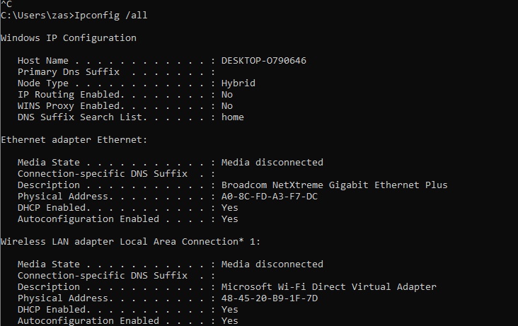

**getmac**

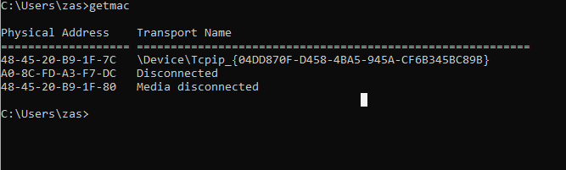

**Seen, not seen, or not Valid IP**

**1 - 10.10.10.10 /24         10.10.10.11/24     Seen**

**2- 192.168.1.10/24        192.168.2.20/24     not seen**

**3-   172.168.168.5/24        172.168.168.210/24  Seen**

**4-  192.168.1.125/25          192.168.1.130/25  not seen**

**5 -   192.168.5.50 /16     192.168.100.100/16 seen**

**6 -   192.168.10.10/26        192.168.10.50/26    seen**

**7 – 192.168.100.30/27      192.168.100.35/27  not seen**

**8-  200.200.200.200/24      200.200.200.100/24  seen**

**9 – 200.200.200.300/24       200.200.200.150/24 not valid**

**10-   200.10.200.5   /8       200.150.150.150/8  seen**

**11 -   10.10.10.30\27         10.10.10.31\27    not valid**

* **5 - Share folder to your friend**
* **6 -Connect remotely to your friend PC**
* **7 -Ask your friend to help you remotely**
* **8 -Add 4 DNS to your NIC**
* **9 -Add three IPs to your NIC**
* **10 -Try to control your PC remotely by team viewer program from your smart phone**